REVISION WORKSHEET
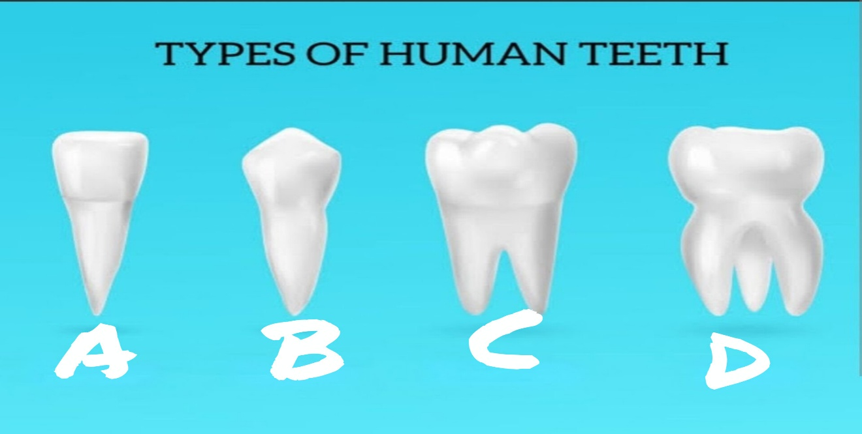
Q. look at the following diagrams and identify A, B,C,D marked on it .
1.

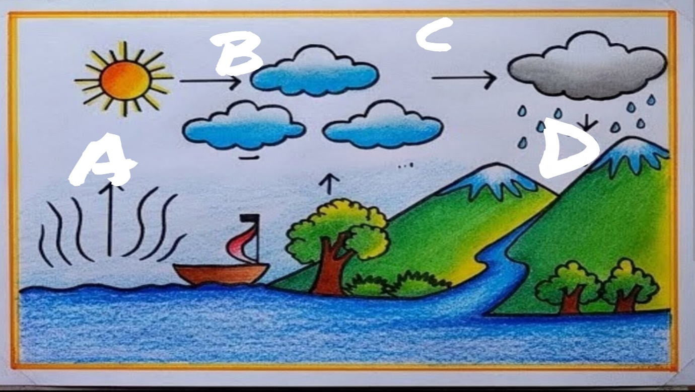
2.

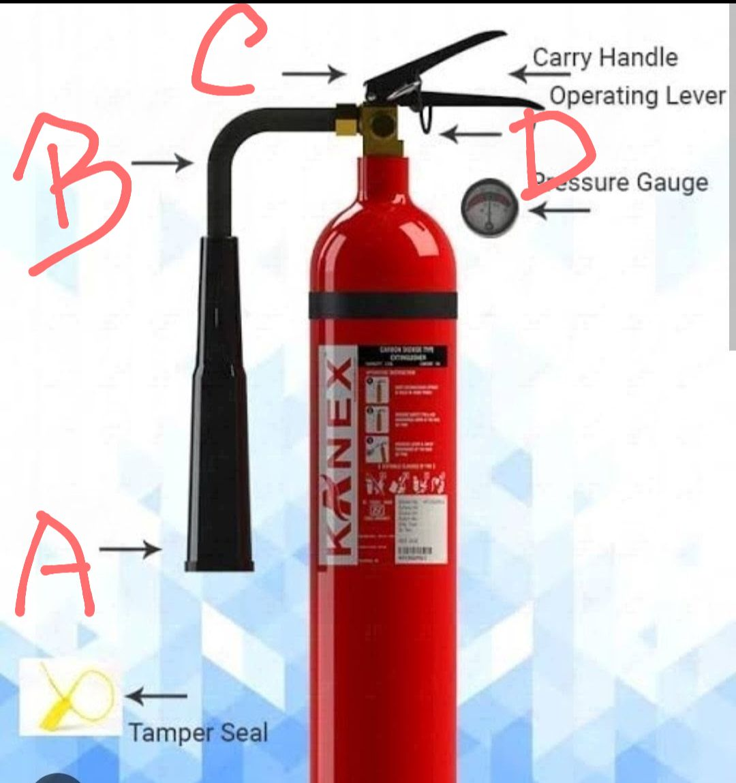
3.

